**Change Jenkins port:**

* We can change the port at /etc/sysconfig/Jenkins as below

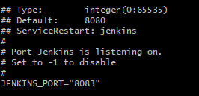

* Restart Jenkins after this

**Jenkins high availability:**

* We create two Jenkins masters on two instances

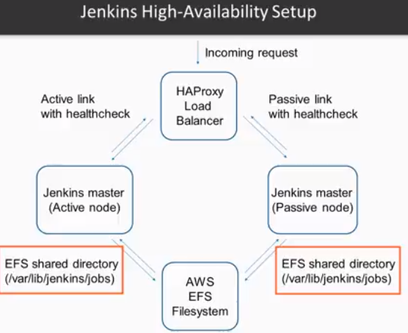

**Security in Jenkins:**

* In Jenkins dashboard, create the password of admin user
* And then delete the adininitialpassword file in secret folder
* And under global security settings, enable the security and assign the permissions to users either using role based or the default way
* Then disable SSH server as below



**Blue ocean plugin:**

* Blue ocean is a new interface to user
* After downloading the plugin and restarting the Jenkins, we get the below option



* By clicking on open blue ocean option, we will get into the new UI

**Jenkins configurations:**

